How to Install the CharlieDaTuna 13/22xx Hammer Debounce Device (HDD).

1. Make sure the gun is unloaded and uncharged. SAFETY FIRST!
2. Place Safety Button in "SAFE" position.
3. Cock.
4. Remove Breech Screw (Fig. 1).

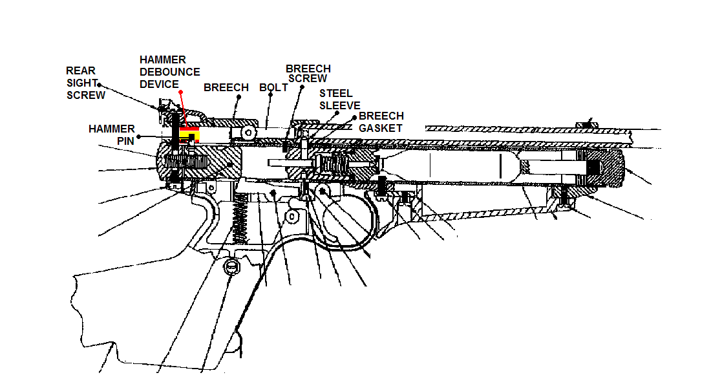
Figure 1
5. Remove Rear Sight Screw.
6. Lift off Breech and Barrel.
7. Insert HDD into Breech (Fig. 2, 3, and 4).
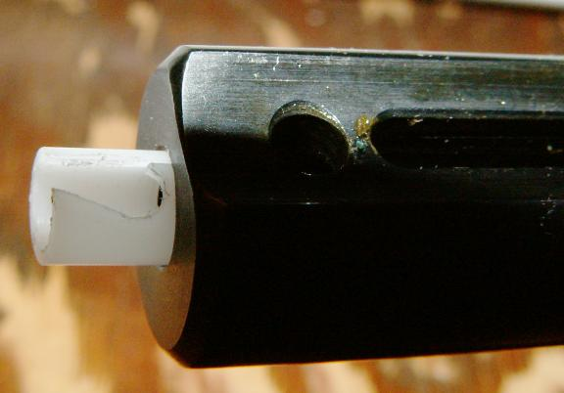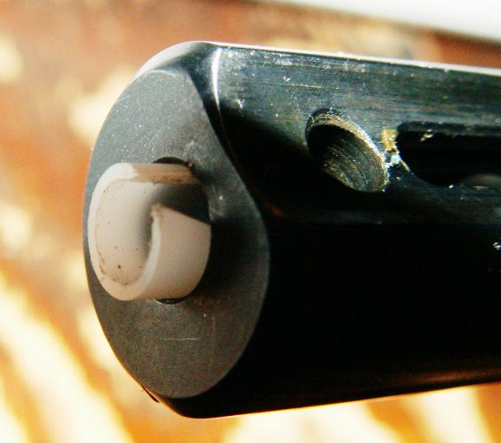
Figure 2 Figure 3

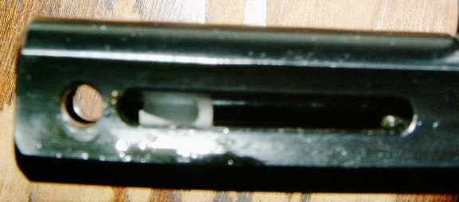
Figure 4

8. Align round hole in HDD with Hammer Pin (Fig. 5).

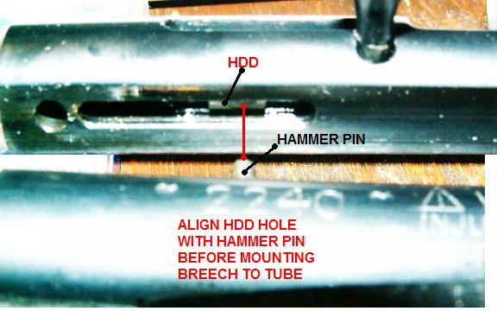
Figure 5

9. Replace Breech and Barrel. Make sure that Steel Sleeve inserts into Gasket and Hammer Pin inserts into HDD (Fig. 6).

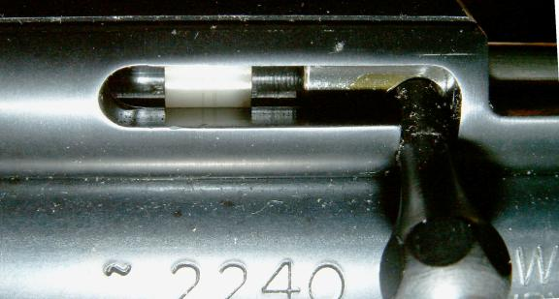
Figure 6
10. Reinstall Breech Screw.
11. Reinstall Rear Sight Screw.
12. Add a drop of 30W non-detergent oil or similar lube to the HDD through the bolt handle slot after assembly. It isn't a good idea to be operating it in a bone dry bore.
13. Charge and test gun. Please note that repeated dry firing of the uncharged gun may damage the HDD and is not recommended.

Note about the Crosman fill-plug: The Crosman steel breach is supplied with a decorative plug that fills the hole in the end of the breech. This plug has no function except to fill the hole. However, the plug can't work with the HDD because it takes up too much room in the breech forward of the Rear Sight Screw. If you install the fill-plug, the gun won't cock.

So two alternatives are available:

1. You can omit the plug entirely - thereby making the gun a little lighter and eliminating the problem. Since the end of the breech is blued and finished, Charlie thinks this option works just fine and doesn’t degrade the appearance of the gun at all.

But tastes differ. So...

2. You can cut or grind the front end off the plug, making room for the HDD.
If you choose this route, you'll need to take off enough material to just begin to break into the hole in the plug provided for the Rear Sight Screw.

