Installing the GRT-4G trigger in Gamo guns with the plastic triggers.
These instructions apply to both spring guns and gas ram (IGT) powered guns.
Revisewd 7/12/13
CharlieDaTuna

Be sure to read the special note near the bottom of these instructions when installing in guns using a gas ram. If not properly installed, your gun will not cock when assembled.

CAUTION
Please read this in it’s entirety before beginning the project.

Reading this entirely, maybe even two or three times, will make it much easier and understandable as you are working on your gun. Although it looks like a lot when reading, it’s really quite simple. I try to be as thorough as possible to make it easier for you and for it to be an enjoyable project. Take your time and think about what you are doing as you are doing it.

WARNING…WARNING…WARNING

DO NOT ATTEMPT to remove the plastic cover on the trigger assembly (under the glide and held in place by the two small screws) without first removing the trigger module from the action first. To do so will cause immediate and irreparable damage to the cover and trigger assembly and will cause the trigger to no longer function properly. Also, the damaged parts are not available from Gamo or any other source. YOU HAVE BEEN WARNED and I can’t help you.

Important: If you do not possess some mechanical and tool skills, or do not have the correct tools needed to do this project safely, don’t. Remember, unless done properly, it can be dangerous. If in doubt, it would better left to a professional or a mechanically inclined person.

Be careful not to lose any parts because it is very difficult if not impossible to get Gamo replacement parts.

NOTICE: Gamo has introduced a change in the action beginning the first of the year in some of their guns. In the future, I will be referring to the new action with the two pins as the GENERATION II ACTION or GEN-II.
The new GEN-II action has two cross pins instead of the single cross pin that we are accustomed to. The new front pin retains the spring or IGT while the rear pin holds the trigger block in place. See the picture showing the two cross pins and their location. (A) In the picture is the sear and (B) is the rear cross pin. The cross pin marked (C) in the front is the new addition.
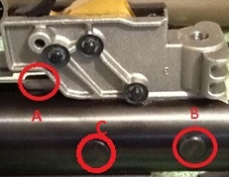
The advantage on the GEN-II action as far as the GRT-4G trigger installation is concerned is that you no longer need to compress the spring or IGT to remove the rear cross pin. Just simply push the pin (B) out. The rest of the installation procedure for the GRT-4G trigger is the same as the earlier model action.

GENERATION 1 guns… You must use a spring compressor for the GRT-IV installation if installing a new spring during an installation or tune procedure.

It is suggested to use a spring compressor for disassembly and assembly. Keep in mind that there is a considerable amount of pressure here and up to from 2 to 4 inches of relief before the spring is completely decompressed.

That said, it is possible to install the GRT-4G trigger blade without a spring compress and if a new spring is not going to be installed. This is because the spring has been set and is shorter than a new spring. It does require two people to make it easier and for safety reasons. PLEASE….. if in doubt, use a spring compressor. More later regarding this.

Also, if you have a gun with a gas ram or (Gamo IGT), although you need to only depress the trigger block a few thousandths to relieve the pressure on the pin enough to remove the pin, it requires a lot of applied pressure. It also requires a lot of pressure to reinstall the pin. It requires depressing the trigger block about 1/16 to 3/32 of an inch to reinstall the pin. It does take a lot of pressure to depress it, can be difficult and I suggest using a spring compressor.

If installing a new spring during assembly, a spring compressor is a must to avoid a possible accident and injury.

The first step of course is disassembly. Be sure that the gun is not cocked.

Now dismount the scope and rings from the scope from the gun.

1. Remove two stock screws at the forearm. Remove the rear trigger guard screw. The screws will differ from gun to gun but most need either Phillips screw driver or #25 Torx screw driver. The #25 screw driver is available at just about any hardware store.

NOTE: On many guns, the screws are covered by pads on the fore stock that pop off by slipping a small screw driver under them enough to get a grip on it and popping them off. When reinstalling, just pop them back on.

Separate the action and stock, and remove the plastic end cap from the rear of the action if applicable.
NOTE: Be aware of the little roller and washer on the side of the cocking linkage and the little “u” shaped glide that sets in the notch on the under edge of the cocking linkage. It acts as a glide between the action and the linkage to keep it from rubbing metal to metal. DO NOT LOSE THESE PARTS.

Now look at the pictures below. This is what you should see when the stock has been removed. If not, then we have a problem…lol… Let’s get started.
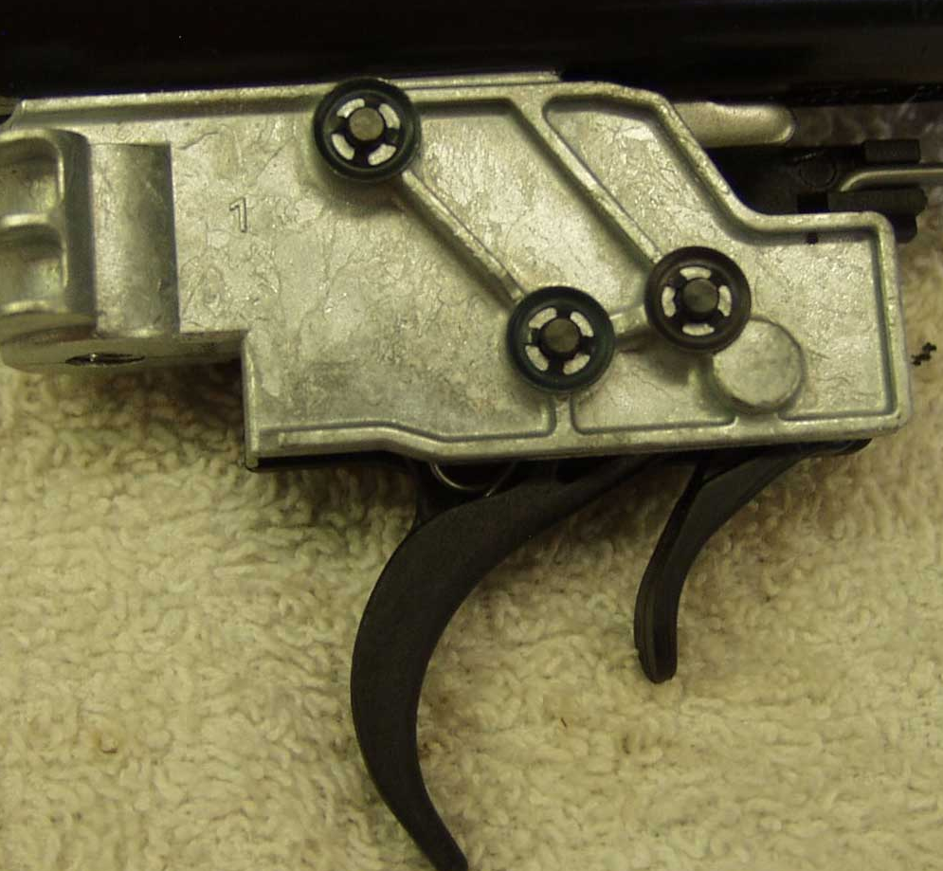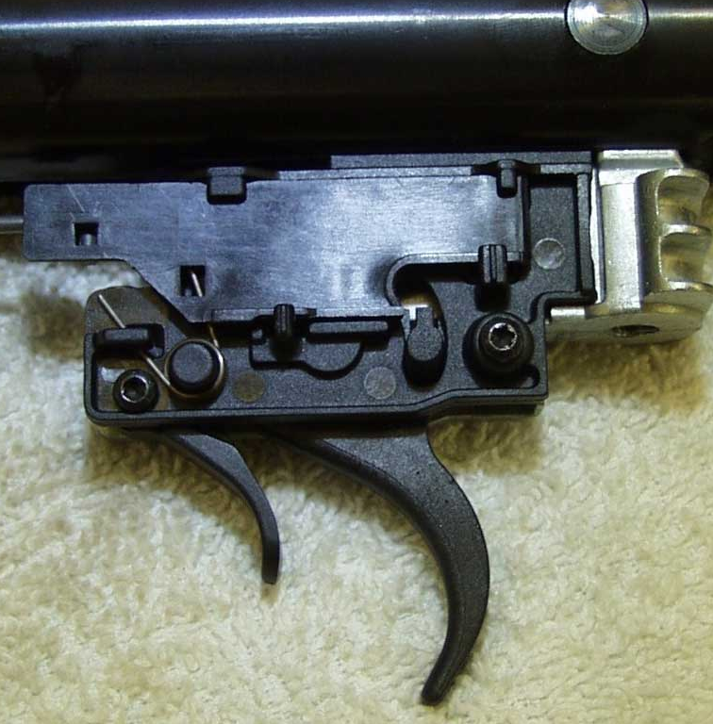
Take notice of the bear trap link (the long wire attached on one end to the cocking linkage and other end connected the plastic guide/slide on the side of the trigger). You will see on the side of the plastic guide/slide and a torsion return spring. Carefully note the orientation of the torsion return spring and how it is installed and to be reinstalled. Remove this spring and set it aside.
Lift the front edge of the bear trap plastic glide that the beartrap linkage is connected and it slide out of the trigger housing.
Note the large cross pin that passes through the action and trigger block. This pin must be removed to release the pressure of the spring in the action and remove the trigger assembly.
WITH A SPRING COMPRESSOR IN PLACE, slightly compress the trigger block enough to take the pressure off of the cross pin and push out the cross pin. Back out the spring compressor to release the pressure on the spring. The travel is about 2-3 inches, and now the spring should be decompressed.
As you decompress the spring, the entire trigger block assembly will come out. Slowly release the pressure on the action until the spring has decompressed and the trigger assembly is free and removed.
IMPORTANT NOTICE HERE … if the trigger block will not come out
If the modular trigger will not come out after the pin has been removed, then reinstall the cross pin. With the action facing up and looking down on the top of the scope rail you will see a slotted screw setting down in a hole of the rail. This screw is going through the action and into the aluminum trigger block preventing it from letting the block slide out when the cross pin has been removed. This screw will need to be backed out three or four turns. Now remove the cross pin and slide it out. It may hang up a little because of the burr caused by the screw but can be tapped out. Once the trigger block has been removed, dress the rough area of the burr with a file or little sandpaper. Be sure to retighten the screw before mounting the scope.
NOTICE…. If your gun has a gas ram rather than a spring, pay close attention when the trigger assembly is removed from the gun and gas ram and how the shaft and bushing comes out of the trigger housing as it is removed. It must go back together the same way and be properly seated or the gun will not cock when reassembled.

ALTERNATIVE METHOD
Installing the GRT-4G without using a spring compressor
As you decompress the spring, the entire trigger block assembly will come out. Slowly release the pressure on the action until the spring has decompressed and the trigger assembly is free and rem
You must use a spring compressor for the GRT-IV installation if installing a new spring during an installation or tune procedure.
I suggest that you have another person assist you with the following. It will be much safer and much easier. One person will be applying pressure to the action while the second person is removing and installing the cross pin.
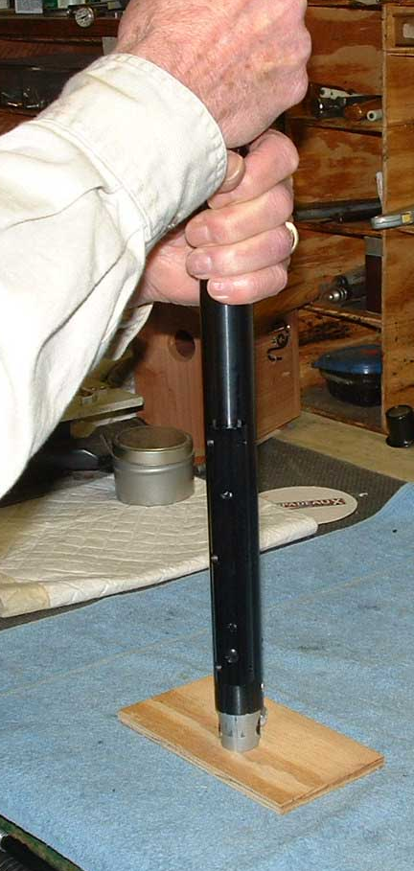
These instruction are essentially the same as above but done by hand instead of using a spring compressor.
Again, take notice of the bear trap link (the long wire attached on one end to the cocking linkage and other end connected the plastic guide/slide on the side of the trigger). You will see on the side of the plastic guide/slide and a torsion return spring. Carefully note the orientation of the torsion return spring and how it is installed. Remove this spring and set it aside.
Lift the front edge of the bear trap plastic glide that the beartrap linkage is connected and it slide out of the trigger housing.
Note the large cross pin that passes through the action and trigger block. This pin must be removed to release the pressure of the spring in the action and remove the trigger assembly. Here’s how.
With the stock removed, stand the rear of the action on end with the barrel facing up on a hard non-slip surface. Grasp the action by the tube (not by the barrel) firmly and push the action down against the hard surface just enough to take the pressure off of the cross pin. (It takes very little, just a few thousandths to take the pressure off of the pin) With the pressure off the pin and using a small punch or screw driver, push the cross pin out. It will come out easily.
An alternative method: Again, I suggest two people.
With the gun on a flat surface like a bench and with the barrel cocked at a ninety degree angle and against a hard strong surface, like a wall, place a small block of wood under the rear of the action in front of the cross pin. It must be thick enough to allow the pin to be removed. Using another block of wood against the trigger block, depress the block in enough (just a few thousandths) to remove the pressure off of the cross pin to push it out. Use the same method to reinstall the trigger block and cross pin.
As you decompress the spring, the entire trigger block assembly will come out. Slowly release the pressure on the action until the spring has decompressed and the trigger assembly is free and removed.
IMPORTANT NOTICE HERE … if the trigger block will not come out
If the modular trigger will not come out after the pin has been removed, then reinstall the cross pin. With the action facing up and looking down on the top of the scope rail you will see a slotted screw setting down in a hole of the rail. This screw is going through the action and into the aluminum trigger block preventing it from letting the block slide out when the cross pin has been removed. This screw will need to be backed out three or four turns. Now remove the cross pin and slide it out. It may hang up a little because of the burr caused by the screw but can be tapped out. Once the trigger block has been removed, dress the rough area of the burr with a file or little sandpaper. Be sure to retighten the screw before mounting the scope.
NOTICE…. If your gun has a gas ram rather than a spring, pay close attention when the trigger assembly is removed from the gun and gas ram and how the shaft and bushing comes out of the trigger housing as it is removed. It must go back together the same way and be properly seated or the gun will not cock when reassembled.
Note the rubber inserts that are in the cross pin holes on each side of the trigger block. Don’t lose them.
>>>>>>>>>>>>>>>>>>>>>>>>>>>>>>>>>>>>>>>>>>>>>>>>>>>>>>>>>>>>>>>>>>>>
Unless you are considering more work on the gun, there is no need to take any of the internals other than the trigger assembly out. Just set everything but the trigger assembly aside.

NOW LETS WORK ON THE TRIGGER
Prepare yourself a clean litter free work area and a clean towel or something similar to work on.
BE CAREFUL OF THE 2 SMALL TORSION SPRINGS THAT CAN FLY OUT AND DISAPPEAR. DO NOT LOSE THEM. THEY WILL BE VERY DIFFICULT TO REPLACE.
Remove the spring guide, plastic spring block and steel washer from the trigger block.
Either remove the factory adjustment screw that sets behind the trigger or just back it out three turns. (This adjustment screw will not be used after the GRT-4G trigger is installed).
With the plastic cover side facing up, you will see mounted on the side of the plastic cover, a torsion spring. Note its orientation and how it is installed. Remove this spring and set it aside.
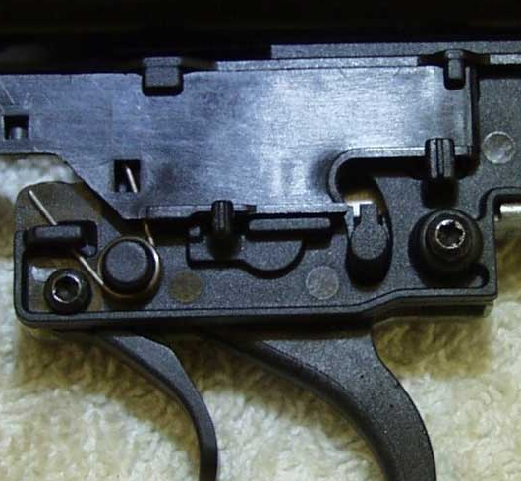
NOTE: You will need either a small Phillips screwdriver or the #8 Torx screw driver or bit to remove the cover screws. That said though, they are screwed into plastic and a person can take a small pocket blade screwdriver and grind it down just a tiny bit at a time to a good fit catch the screw and unscrew them. We did it to test it and it was no problem as they are not real tight due to being screwed into plastic and are so small. (The #8 Torx screw driver or bit should be available at most good hardware stores) Carefully work the cover off of the trigger exposing the internals.
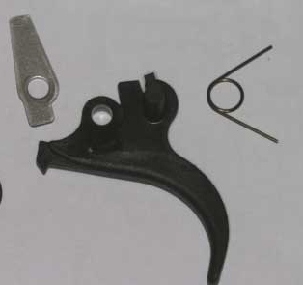
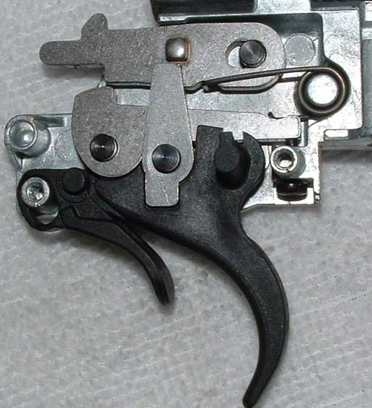
Remove the little metal bear trap block that sets on top of the plastic trigger. Note it’s orientation on the trigger.
Using a small screw driver push the spring loaded intermediate lever up (see picture below) towards the sear lever and lift out the plastic trigger. Note that there is a torsion spring inside behind the trigger that will come out with it. (This spring will not be reinstalled with the GRT-4G trigger).
If the plastic safety switch did not lift out with the trigger, remove/lift out the plastic safety switch. Note the orientation of the switch and the little hole that the safety pivot sets in. Note how the nose of the trigger sets in the slot of the safety switch.
PLEASE NOTE THAT THE LATEST PRODUCTION OF THE GRT-4G TRIGGER BLADE DOES NOT HAVE THE 1ST STAGE ADJUSTMENT SCREW. It will also no longer have the hole where the spring is visible.
The next step is a little tricky and requires that the safety switch and trigger be installed at the same time almost as an assembly and at the same time raising the spring loaded intermediate lever to clear the trigger and may require an extra set of hands depending on your dexterity. One to hold the lever up while installing the trigger.
Using your small screw driver push the spring loaded intermediate lever up again towards the sear lever. With the lever pushed up, install the GRT-4G trigger on the trigger pivot and the safety switch with the nose of the trigger setting in the slot of the safety while inserting it in its pivot hole. A little tricky huh…lol…
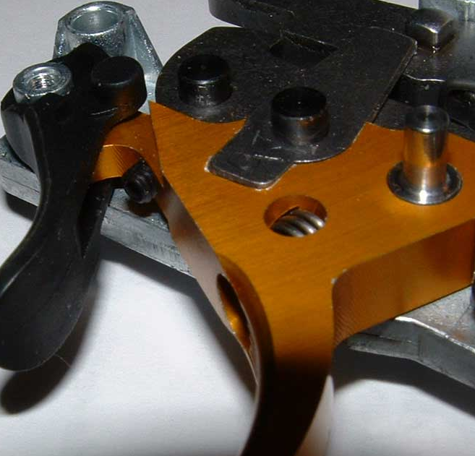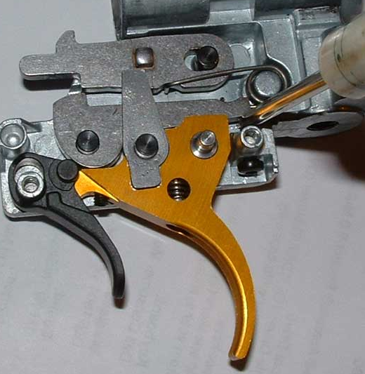

Install the little metal bear trap block on the new trigger in its proper orientation so that it sets into the side of the trigger. It may be a tight fit and may need to be tapped with a small hammer to seat. It should seat just about flush with the surface of the trigger. NOTE: Another suggestion if it is a tight fit …. Before installing the trigger into the housing, you can lay the trigger on a flat surface, position the block in place and gently tap it into the recess and then install it as an assembly.
Install the supplied fat pin into the fat pin hole of the trigger with the small side of the pin facing out.
Set the safety switch in the engaged position. Reinstall the cover the cover and screws
Move the safety switch on and off.
NOTE: The safety switch may be stiff to move the first couple of times that it is engaged and disengaged
NOTE…. Check this: With the safety off, move the trigger back and forth to be sure that it is free moving and that there is no interference. Be sure that the fat pin moves in the slot and does not come in contact with the surface edge of the slot in the cover. If it does, you may need to file the surface slightly for the needed clearance. Also, the safety switch is pretty solid and does take a little effort in some triggers to switch on and off. This is normal.
ALSO…. Check this: Be sure when moving the trigger back and forth that the bear trap block that sets into the side of the trigger is not rubbing on the inside of the plastic cover. If it is, remove the cover and reset the bear trap block so that it is setting deeper in the recess of the trigger.

AND FINALLY…. Check this: While pulling the trigger back and forth, be sure that the nose of the trigger that sets in the slot of the safety switch is not coming in contact with the plastic in the switch. Although there have been no incidents of it, it was something that we thought might possibly be encountered.

Now let’s check the adjustments
PLEASE NOTE THAT THE LATEST PRODUCTION OF THE GRT-4G TRIGGER BLADE DOES NOT HAVE THE 1ST STAGE ADJUSTMENT SCREW.
There are two reasons for this. One is that the geometry is such that the optimum adjustment has now been built into the trigger blade and two, it prevents accidently disabling the safety.
The trigger pull weight cannot be adjusted.
Initial adjustment check…. Although you’re GRT-4G trigger was pre-adjusted prior to shipping, let’s check it.
The stainless steel slotted screw is the second stage adjustment.
Check to see when you move the trigger back and forth if you feel the second stage bump. If not, adjust the second stage screw back and forth in very small increments until you feel it. The second stage will be a slight bump. Keep in mind that the trigger pull weight will be heavier and the bump feel much lighter when it is actually under a load and may need to be readjusted once installed. The final feel may be totally different and to be expected.
Reinstall the spring guide, plastic spring block and steel washer in the trigger block. Also, be sure that the rubber inserts are in the cross pin holes on each side of the trigger.
Reinstall the trigger assembly by assembling it in the reverse of the disassembly in the instructions above. Reinstall the safety glide and then install the torsion return spring for it.
Reinstall the trigger into the gun and reassemble the action using the reverse assembly process that you disassembled it with.
IMPORTANT NOTE……… IF YOU’RE GUN HAS A GAS RAM POWER PLANT
When reinstalling the trigger block during reassembly of a gun using a gas ram power plant, be sure that the silver rod end and bushing of the gas ram that goes up inside the trigger housing is properly aligned and seated up inside the trigger housing. If it is not properly seated, your gun will not cock when done.
You may want to fine tune your trigger to your feel. When making adjustments to the second stage, do it in very small increments
That’s it… your done. Have fun, happy shooting and be safe.
SEE THE TROUBLE SHOOTING GUIDE BELOW

TROUBLE SHOOTING SECTION

CANNOT REMOVE THE MODULAR TRIGGER BLOCK AFTER REMOVING THE CROSS PIN.
If the modular trigger will not come out after the pin has been removed, then reinstall the cross pin. With the action facing up and looking down on the top of the scope rail you will see a slotted screw setting down in a hole of the rail. This screw is going through the action and into the aluminum trigger block preventing it from letting the block slide out when the cross pin has been removed. This screw will need to be backed out three or four turns. Now remove the cross pin and slide it out. It may hang up a little because of the burr caused by the screw but can be tapped out. Once the trigger block has been removed, dress the rough area of the burr with a file or little sandpaper. Be sure to retighten the screw before mounting the scope.
YOUR GUN WILL NOT COCK
This is very rare if all else has been installed properly but if it happens, it is usually because the trigger is is not properly adjusted and the adjustment screw is adjusted in just a little too far. Simply turn the slotted 2ND stage counterclockwise screw slightly in very small increments and checking as you go. It normally should not need to go more than ¼ turn. Keep in mind where you started so that you can return to that point if need be.
If that does not resolve the problem, then you probably have an incorrect installation problem.
OTHER ISSUES
The biggest problems will be the fact that the parts are stamped or plastic and the variance in tolerances in the factory parts that may cause clearance interference. This can cause the trigger to hang up or to not be free to move forward after the gun has been cocked and fired. They were covered above but here they are again.
NOTE…. Check this: With the safety off, move the trigger back and forth to be sure that it is free moving and that there is no interference. Be sure that the fat pin moves in the slot and does not come in contact with the surface edge of the slot in the cover. If it does, you may need to file the surface slightly for the needed clearance.
ALSO…. Check this: Be sure when moving the trigger back and forth that the bear trap block that sets into the side of the trigger is not rubbing on the inside of the plastic cover. If it is, remove the cover and reset the bear trap block so that it is setting deeper in the recess of the trigger.
AND FINALLY…. Check this: While pulling the trigger back and forth, be sure that the nose of the trigger that sets in the slot of the safety switch is not coming in contact with the plastic in the switch. Although there have been no incidents of it, it was something that we thought might possibly be encountered.
* If you cannot engage the safety. It is unlikely this will be encountered but if so… If pulling the safety to the safe position and it will not engage. NOTE: The safety switch is pretty solid or stiff and does take a little effort in some triggers to switch on and off, especially the first few times that it is engaged and disengaged. This is normal.
Looking at the tip of the hooked nose of the GRT-4G trigger you will see the sharp tip on the nose. Using a small file, simply file that sharp nose surface edge evenly and very very slightly. It will require only a thousandths or so of surface removal to provide the clearance needed.
IF THE SECOND STAGE SCREW WILL NOT HOLD IT ADJUSTMENT
If the screw is actually loose and loses its adjustment:
If the screw becomes loose and will not hold its adjustment, you can while counting the turns, remove it. Then clean it removing any oil with fingernail polish remover and reinstall it using fingernail polish, Blue LocTite or RTV. Reinstall the screw turning it in the same amount of turns that you counted while removing it. Check and adjust it before the holding chemical sets.
An alternative is to remove the screw while using the same above removal process. Then using a pair of sidecuts (diagonal wire cutters) slightly distort or nick/cut across one or two threads (enough to cause holding friction when reinstalled) at about the center of the adjustment of the screw. Reinstall the screw and adjust.
THE TRIGGER HAS A VERY SHORT PULL BEFORE FIRING OR ALMOST A HAIR TRIGGER

It has come to our attention that a couple of the late Gamo’s with the modular and SAT triggers have a short pull hair trigger. This is an extremely rare condition and it is not the fault of the trigger but rather either a slight change (imperfection) in the intermediate lever or, the lever has a slight manufacturing defect.

The repair or fix is very simple and easy, especially if you have a Dremel tool. A file will work just fine though. Using your tool or file, remove about ½ of the little hump on the surface on the upper side on the side of the trigger. Check to see if that improved or resolved the problem. If need be, you can file additionally file the hump down until it is flush. See the red circled area in the picture of the trigger below.

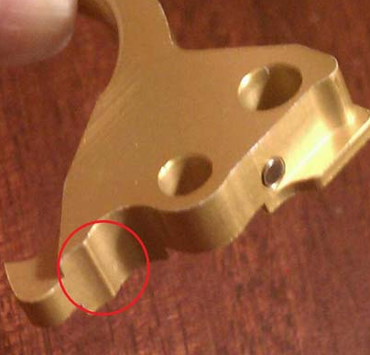

You can if you like increase the travel by making a small channel where the hump was just a little deeper than flush using a round file if you like. It doesn’t take much so you must be careful not to go too far. Check it as you go. Remember.. you can’t put it back…lol…

If you would rather not mod the GRT-4G trigger and return it for a refund then do nothing to the trigger. Just e-mail me for return information.

WARNING …….Important Safety note regarding balked fires:
When starting to shoot and a decision is made not to follow through and you release the trigger (balk fire), the trigger sear does not reset.
If you start to pull the trigger, but then release it without firing, the sear will not reset to its original (as-cocked) state automatically. This may leave your rifle on the verge of firing and therefore in an unsafe condition where the slightest jolt or vibration might cause a misfire. Therefore, if you begin to take a shot, but then change your mind after having already started to pull the trigger, it is important to always either re-cock the gun to reset the sear or fire the gun in a safe direction or into the ground.
The non-resetting sear is not a side effect of the GRT-4G trigger blade modification. It is like that in all Gamo rifles and Gamo clones (or any springer for that matter) whether the new models or early models. You probably never noticed it before only because the blade return spring of the unmodified trigger creates the illusion of automatic reset when the trigger blade is released. A partial pull-through has always had this potential for leaving the sear in a state of partial disengagement. I suggest that you always re-cock the gun or fire the gun in a safe direction or into the ground whenever a trigger is even touched without actual firing on any gun.

