Determining Which Trigger To Order

Because different applications may use different triggers in some later guns, only you can determine for sure which trigger to order for sure.

If you will remove your stock, you can look to see which trigger you will need to order and order the correct trigger. The first set will use GRT-4G trigger. The second set will use the GRT-III trigger and the third set will use the CBR trigger.

Does your trigger look like the trigger module below? If so, The GRT-4G trigger will work. These are used and will work in late model Gamos only.

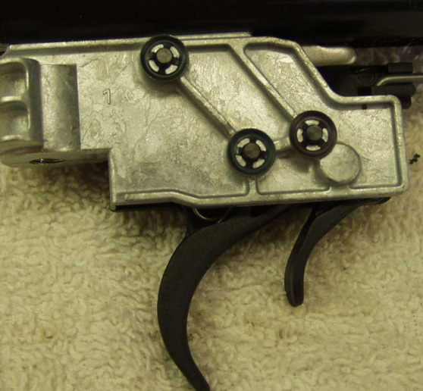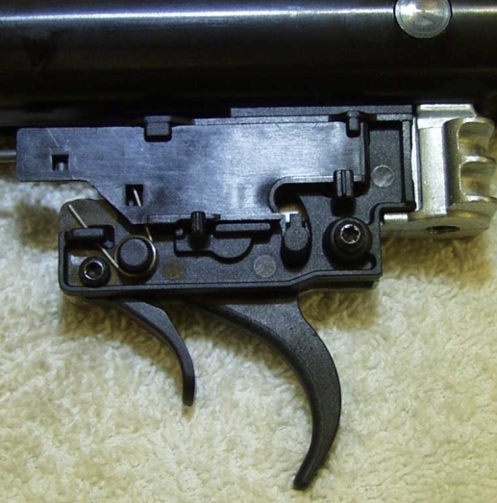

NEXT….Does your trigger look like the trigger below? If so, The GRT-III trigger will work. These fit in almost all early Gamos and Gamo clones, Crosman and a multitude of others springer’s. Some may have slight variations.

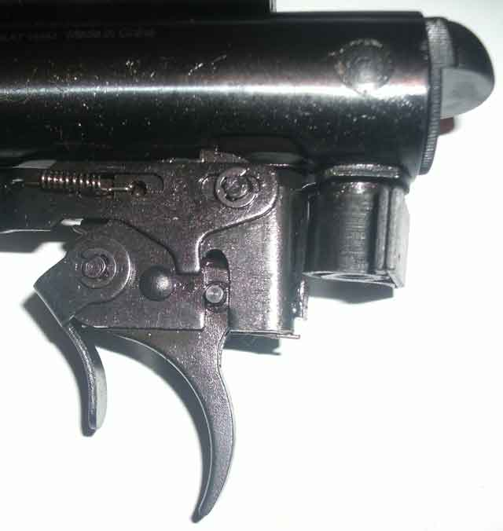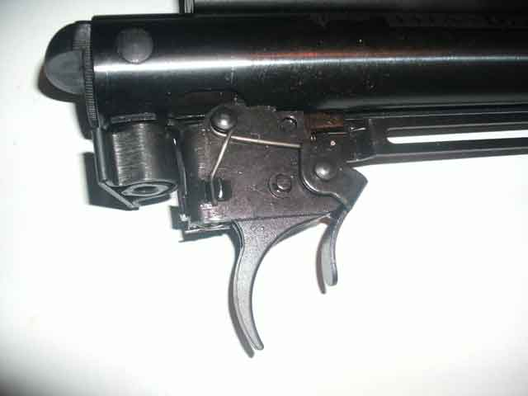

NEXT
Does your trigger look like the trigger below? If so, The CBR trigger will work.
(Sorry for the poor quality pics but the only ones I had).

These fit Crossman NPSS, Remington NPSS, and also fit the Remington Genesis
Remington Legacy with the plastic triggers as well as some Crosmans like some Phantoms. Some Phantoms may use the GRT-III trigger.

Please note the area on the factory original plastic trigger below where the red circle is and located in the lower left picture. That is what determines that it takes the CBR trigger. If your trigger resembles that, then order the CBR trigger.



